Steps for CMake Hello World Program

based on: https://www.youtube.com/watch?v=SHw5zVM5qGo&t=5s

$ mkdir my_program
$ cd my_program/
$ touch CMakeLists.txt
$ touch my_program.cpp
$ ls
$ code .

CMakeLists.txt
cmake_minimum_required(VERSION 3.16)
project(MyProgram LANGUAGES CXX)

set(CMAKE_CXX_STANDARD 20)
set(CMAKE_CXX_STANDARD_REQUIRED ON)
set(CMAKE_CXX_EXTENSIONS OFF)

add_executable(MyProgram my_program.cpp)

my_program.cpp
#include <iostream>

int main()
{
std::cout << "Hello World!\n";
}

In VS Code, Select Terminal → New Terminal
$ mkdir build
$ cd build/
$ cmake ..
$ cmake --build .

This shows the program “MyProgram” has been built

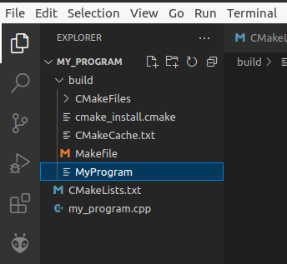

To run the program: $ ./MyProgram

